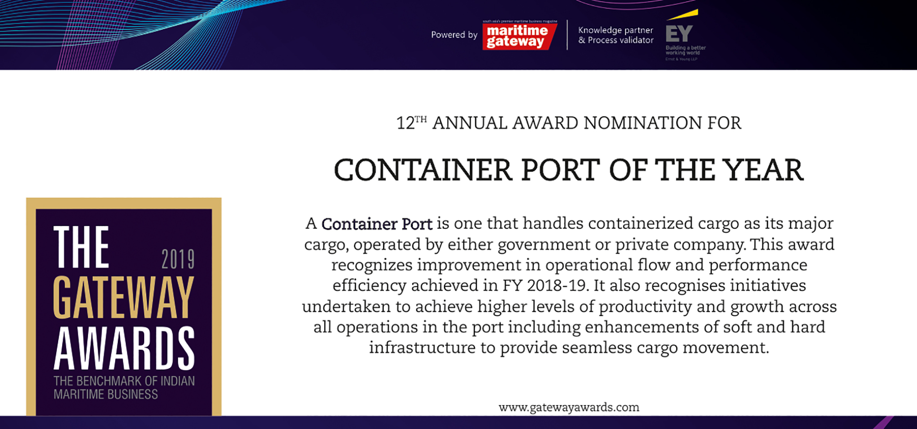

Please fill your responses and mail it to the address mentioned at the end of the Questionnaire

Note: All information and data should be provided for the FY 2018-19. In case, if you are unable to provide FY 2018-19 data, CY2018 information can be sent with a reason for not providing data for FY2018-19.

Contact information
Name of the Organization

Contact Person

Designation

Contact no.

Official Email ID

Address

Performance Indicators

Parameters | Units | Inputs
Throughput ( Including Transhipment) | TEUs | Imports (2018-19) |  | Exports (2018-19)
Throughput ( Including Transhipment) | TEUs | Imports (2017-18) |  | Exports (2017-18)
Transhipment Volume | TEUs
Coastal Volume | TEUs
Installed Capacity | TEUs
Capacity Added | TEUs
Yard Area | Hectares

Efficiency Indicators

Parameters | Units | Inputs
Capacity utilization | Percent
Average turnaround time | Days
Growth in Average Turnaround time (Y-o-Y, FY2018-19 over FY 2017-18) | Percent
Average pre-berthing detention time | Days
Growth in Average pre-berthing detention time (Y-o-Y, FY2018-19 over FY 2017-18) | Percent
Average output per ship berth day | TEUs
Growth in Average output per ship berth day (Y-o-Y, FY2018-19 over FY 2017-18) | Percent
Average Crane Productivity | Moves per hour
Growth in average Crane Productivity(Y-o-Y, FY2018-19 over FY 2017-18) | Percent

Infrastructure Enhancements

Parameters | Type of inputs needed | Inputs
Commissioning of new equipment  (Quay cranes, RTGCs, RMGCs,  Reach stackers, Forklifts...etc) | Number, type,  manufacturer of equipment and rated capacity
Construction of new berths | Number and capacity in TEUs
New Services and routes added | Service Name ( ex: CIX  express) and Port callings
Connectivity Improvements | Road and Rail  connectivity enhancement/addition
Entry in new global markets | Name of the countries

Innovations/ Investments/ Enhancements

Parameters | Type of inputs needed | Inputs
Innovations | • Qualitative inputs  • Word limit ~ 200 words.
Business Processes

Efficiency

Technology

Investments made

Please use below contact for sending filled-in form and also for any queries.

Rakesh Oruganti | Cell:+91 9948334568;E mail ID: rakesh.oruganti@gatewaymedia.in

